Anzac Assembly 2019
Denise Lofts

I would like to acknowledge that this presentation is being held on Aboriginal land and recognise the strength, resilience and capacity of our Murramarrang people of this land.
Thank you to all our very special guests, your support of our school has more power than you know. We are extremely appreciative of your presence.
‘Changing Attitudes to War’ as a lens for learning
The theme ‘Changing Attitudes to War’ as a lens for this year’s Anzac Assembly resonates vividly in the psyche of our school, and within the understanding of our place in the future views of our country and its people.
When the year 9 students last year created an entire project around their deep dive into Remembrance Day, it sparked a learning journey that was deep and meaningful. Their driving question was:
“We don’t understand war, we haven’t experienced it first hand, we want to know more so we can learn to understand both peace and war.” (Year 9 Commerce students)
…and it was that question that enlivened their interest and served as the enthusiastic driver behind our authentically supported Remembrance Day Dinner, and which helped our students truly understand the notion of war. Those Remembrance events took place here in this big room, like other events across the country on the 11th November 2018, marking the 100th anniversary of the Armistice in 1918, a signal for the end of World War One. You seek to understand. I commend you.
Connecting our students to their community through the Anzac Spirit
Anzac Day 2019 is the seventh year I have spoken to the notion of Anzac as the Principal of this outstanding school. As I do every year, I spend more time thinking and reflecting on my views, my feelings about the future and the past, my understanding and insights of war, than actually writing this passage. I take this opportunity to tell about the hearts and minds of each and everyone one of us. And relish the time to reflect on our position in this modern, empowered (yet disempowered) world and what ‘war, conflict, peace and freedom’ mean to us. And how war in the modern world looks and feels different, particularly for the young people of our school.
Reflecting on the ‘dehumanising’ of others
In the past I have spoken about how our world needs to move to ‘humanise’ each other, as opposed to ‘dehumanising’ others. We need to be ‘Up Close’, looking into the eyes of those who have different beliefs, cultures and views who, like us, are human beings.
We must show empathy.
I spoke of the connection (albeit fragile) of North Korea and the US. I spoke about Leirus, whose wife (the mother of his son) was killed in the Bataclan Theatre bombing in Paris, along with eighty-eight other people. He refused to allow the killers to own his hate, as he declared in an open letter to his wife’s killers posted on Facebook two days after the attacks. Leirus wrote:

“On Friday night, you stole the life of an exceptional being, the love of my life, the mother of my son, but you will not have my hate. I don’t know who you are and I don’t want to know. You are dead souls. If that God for whom you blindly kill made us in his image, every bullet in my wife’s body will have been a wound in his heart.
So, no, I will not give you the satisfaction of hating you. That is what you want, but to respond to your hate with anger would be to yield to the same ignorance that made you what you are. You want me to be scared, to see my fellow citizens through suspicious eyes, to sacrifice my freedom for security. You have failed. I will not change.”
The role of young people in today’s world
The war that exists within a person’s heart is one of the biggest battles of our modern World.
The place young people play in changing this within a generation is upon us. And in the hands of our students today.
Today we are edging closer and closer to a world where political and ideological discourse has become an exercise in dehumanisation. Yet, I stand here and believe that within this generation, things will be different. The youth of today will be the leaders of tomorrow who will change this trajectory. I believe you are totally ‘up for the job’.
In the Dalai Lama’s 2018 manifesto ‘A Call for a Revolution’, he calls upon you, the young people of today to bring on a revolution motivated by compassion, for the sake of your own children and future generations.
He speaks of an unforgettable memory from November 1989, thirty years ago, when Germany was divided into two two hostile states that were separated physically by a 100 km, three metre high concrete wall.
It was known as the ‘Wall of Shame’. Peppered with watch towers, it divided individual families as well as an entire nation. He happened to be in Berlin at the very moment when tens of thousands of young and enthusiastic demonstrators broke through the wall with their bare hands, knocking down frontier posts one by one, entirely peacefully. The whole world held its breath. Young people were changing the course of history. In both East and West Germany, this generation turned its back on ideological confrontation, affirming its desire for German reunification, a reconciliation made possible by politics of transparency, set in motion in 1986 by Gorbachev, the leader of the Soviet Union. He refused to give the order to fire on the demonstrators and later declared that the fall of the Berlin Wall had avoided a third world war. He speaks of the extraordinary moment, and felt the breath of peace and freedom exhaling throughout the world.
The symbolic impact of this momentous event was made even more significant by the fact that in March of that same year there were horrendous images of bloody repression of peaceful demonstrations in Lhasa (Tibet).
And then three months later, in June, tanks crushed a student uprising in Beijing’s Tiananmen Square. But in November, the fall of the Berlin Wall proved that it was possible for young people to proclaim non-violent victory against an oppressive dictatorship. When we reflect back on it today, that event stands as an epilogue to the tragedies of the Twentieth Century. By confirming the imminent demise of communism in Eastern Europe, it put an end to the legacy of the Second World War. The collapse of such regimes reinforced our belief that young people today are committed to universal values of democracy and solidarity. And this event effectively swept away destruction, thanks to this youthful pacifist approach, in which not a single drop of blood was spilled.
As digital natives you were born world citizens, for digital culture has no borders. You are the first truly global citizens. Learn to use your social networks with discernment to speed up and spread awareness of humanity.
“Witnessing huge numbers of young people in opposition to old ideologies that are outdated and every armed conflict provokes demonstrations of peace in major cities around the world. You rally in solidarity for the causes of reconciliation and human rights. Witnessing huge numbers of young people demonstrating in support of humanitarian issues is remarkable. Your mission is to draw lessons from the errors of the past. You will make a difference.” (Dalai Lama)
Even here in Ulladulla, you have shown how you will advocate and have advocated for what the world needs. This was never more alive than on the 15th March 2019 in our school, in the peaceful lunchtime rally on Climate Change. It was one of those times in our school’s history that we will look back on and say ‘Thank You’. All students from year 7 to year 12 spoke up in support of climate change. The rally was respectful, mindful and a celebration of courageous individuals speaking out in support of something greater than themselves.
Recognising our Kokoda Track students
Finally, I want to acknowledge the champions who were incredible in their application for an opportunity to walk the Kokoda Track. Many of you are aware that Ulladulla High School, the Ex-Servicemen’s Club and the RSL Sub-Branch collaborate to select three students to be part of the Kokoda Youth Leadership Trek and 2019 is no different.
It was a very difficult decision. The panel were unanimous in saying any one of the nine applicants was worthy of the award. All of the students are incredible young people who have shown their tenacity, maturity and understanding of the modern interpretation of Kokoda. We look forward to hearing about these students’ journey and have confidence in those who are not chosen to still make an incredible impact on the school and their futures. Huge congratulations to all nine students being presented today.
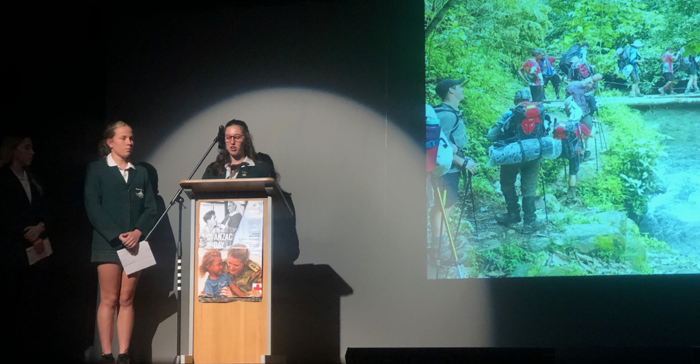

Finally, when I seek to understand the changing attitudes to war, there is never a truer statement:
“Everything that divides us belongs in the past.”
“All those forces of separation and exclusion will be powerless to resist the strength of the desire for peace embodied by your generation.” (Dalai Lama)

The change the world will need is in your hands, ‘the youth of the world’.
Lest we forget.

Contributor details
Denise Lofts (denise.lofts@det.nsw.edu.au) 17/4/19
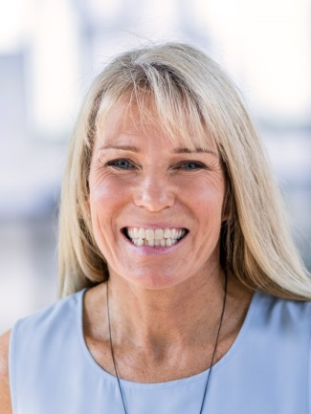
Denise has been Principal of Ulladulla High School since 2013, previously Principal of Marsden High School. Currently she is a member of the SPC Executive with particular responsibilities for Health and Safety and Aboriginal Education. Her current interests also include future focussed learning, particularly authentic cross-curricular project work, mindfulness and principal wellbeing. In addition, Denise is currently working on her Doc Ed with UNSW with a focus on rural and remote school leadership.

