Captains and Prefects Investiture 2015
Fiona Walsh

First may I congratulate the prefects, vice captains, captains and their families for the appointments that you are receiving here today.
The nomination and selection process for the student leadership team is rigorous and you should be justifiably proud of your selection to the West Wallsend HS leadership team. May I also applaud you for your desire to serve your school and the community.
Entering the realm of student leadership remains both a challenge and an honour. Prefects are representatives of the student body and embody the best in student qualities that the school has to offer.
Leaders, please be mindful of this and also of the rich heritage of the West Wallsend HS leadership team as you go about your tasks and duties. This year’s leadership team and the teams preceding you have displayed outstanding commitment to our school and have made a valuable contribution.
You, of course, will be no different.
For some of you, this is your first exposure to true leadership. It will likely be the first in a lifelong journey of leadership – something that West Wallsend has a strong tradition of. As Prefects the experience that you gain through working with numerous people in our learning community, organising events and representing our school, will be great training and experience for your future leadership roles in life.
To those of you who might have wanted to serve as school leader but who were not chosen, do not feel disheartened but use the opportunity as a development experience and continue to seek different avenues for leadership.
I’d like to share a quote from Jack Welch, a very successful business executive in the US. Jack states:
Before you are a leader, success is all about growing yourself.
When you become a leader, success is all about growing others.
The quality of a leader is reflected in the standards they set for themselves and I would ask the incoming leadership team to set the highest of standards possible, for themselves and their fellow students.
I would ask them to reach their potential as leaders by being gracious, humble, mature and committed to making a difference at WWHS.
I know I speak on behalf of the teaching staff when I say that we are looking forward to working closely with each of you over the next year.

Contributor details
Fiona Walsh (fiona.walsh@det.nsw.edu.au ) 19/4/19
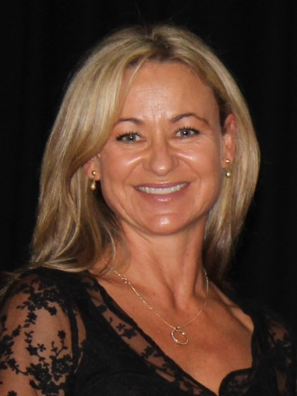
Fiona has been Principal of West Wallsend High School since 2014. Currently she is also President of NSWSPC Hunter Region, Leader of the Professional Learning Reference Group and a Member of the SPC Executive. The focus of Fiona's PhD was professional learning. Her current interests include sport.

