NAIDOC Ceremony 2017
Greg Wilson

1. Acknowledge the Githabul people, traditional owners of this land. Pay my respects to Elders past, present and future and to any Aboriginal people here today. Together we walk towards our future.
OR
Thanks to [name] for their welcome to what was, what is, and what always will be Githabul land.
2. This year’s theme: ‘Our language matters’
- We all know the importance of language
- Shakespeare’s Henry V – language that emotionally connects
- Language is our identity
- Language – body language, art, dance, music
- Link to video of song
- Lucky our community has language and connections to our language – as a community we are enriched when it is shared –
- It helps connects us
- It develops a shared understanding
- However it is important that our actions match our words – our language
3. Racial harmony
- Important role of [Name] in promoting and enabling racial harmony
- We have come a long way over the years
- From time to time events and incidents occur that remind us that we still have a way to go
- However, we now can talk through issues
- We must be eternally vigilant to create the society we want
- We must develop our shared language to help us move forward
4. When given opportunities our students achieve great things:
- Video
- Sporting achievements at all levels
- Performances at Opera House
- Traineeships

Contributor details
Greg Wilson (greg.wilson@det.nsw.edu.au ) 21/4/19
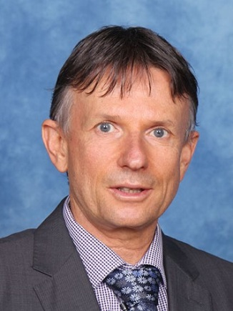
Greg is Principal of Woodenbong Central School, a position which he has held since 2008. In addition, he is a Member of the SPC Executive with responsibility for Learning and Business software, Aboriginal Education, Learning, DoE systems and he also represents the SPC on numerous Program Control Groups.

