On the sudden death of a member of staff
Michael Rathborne

When I was thinking about this assembly over the last week I could not escape the fact that there were several strong purposes.
Firstly, it was important that we as students, staff and a school community not lose sight of the fact that despite setbacks and tragedy, life does indeed go on. We take our setbacks and tragedies and we hopefully learn from them to continue to grow and evolve as individuals and as a community. Thus we have continued as normal for the first part of this assembly.
Secondly, it was important that as a school community we come together to reflect and show our respect to a member of that community who is sadly no longer with us. It is also pertinent to reflect and remember that in all things we learn, and learning should be at the heart of everything that happens in schools, no matter how joyous or how sad.
Finally, it is incumbent on me as the learning leader in the school to do exactly that – to lead the learning. It is sad that perhaps one of the things that we as a species do very poorly is to teach or think about how to mourn. We all too often tend to ignore death in all its forms until it is upon us.
When I thought about [name of staff member] over the last little while I have been conflicted. I have thought about my relationship with him as his boss, where he could often be extremely frustrating. I have thought about watching him in action in the classroom with his students, and the joy, love and wonder that was so evident in that experience for him and the students he taught.
Like anyone [name] was all too human, blessed or cursed with the frailties of the human condition. Some of us will move on more quickly than others, for some of us thoughts of [name] will be ever-present, and yet for others those thoughts will be more ephemeral. I mean no disrespect to [name] when I say that my overwhelming thought when thinking of him was of Peter Pan – the boy who never grew up. I say this not because I think that he was childish but rather because he never lost his child-like wonder in music and its transformative nature. To quote Peter Pan, “To live will be an awfully big adventure” and for him it was.
The Greek poet and playwright Aeschylus wrote 2500 years ago, “He who learns must suffer. And even in our sleep pain that cannot forget falls drop by drop upon the heart, and in our own despair, against our will, comes wisdom to us by the awful grace of God.”
It is a wisdom that I hope in time we can all find a path to. Finally to quote Peter Pan again, “Never say goodbye, because saying goodbye means going away, and going away means forgetting.”
Vale [name].

Contributor details
Michael Rathborne (Email michael.rathborne@det.nsw.edu.au ) 17/4/19
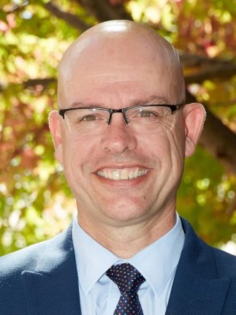
Michael has been a Principal since 2011 and Principal of Uralla Central School since 2014. Currently he is the Central Schools Rep on the SPC Executive. He also represents the NSWSPC on the NSW Department of Education Consultative Committees for Special Religious Education and Special Ethics Education. He is the co-author of several Junior History texts.

