Presentation Night 2018
Denise Lofts

It has been another incredible year with each student continuing to build on their capacity, in preparation for the world beyond. I thank all our supporters, our parents and community, who take the time to work with us. Your support of our students has more power than you know. We take every opportunity to recognise and celebrate the excellence of our students across all areas of their achievements. We thank you for your ongoing advocacy for our school and our students.
Academically, as a large rural school we have continued to excel across external exams, with students gaining university entrances across every field of aspiration including Medicine, Law, International Studies, Health Sciences, Agriculture, Education, Computer Science and Creative Arts. We continue to celebrate the incredible achievements of our Alumni, who have engaged the world, and are literally changing the world. I am in awe of the mark they are making on the world. They are inspiring.
How do you measure a public school?
During 2018, I heard a statement from a colleague Principal about their school and their students. And I feel much the same.
“It is hard to measure the immense impact that Public Education makes for young people. Value adding, the bit that is often so hard to measure, rarely makes that spreadsheet or headline.”
At Ulladulla High School we see it right here – today. A school experience that is hard to measure, it just is. At UHS we build great humans and that is hard to put a mark on. We pride ourselves in adding value to our students’ lives, the richness of experience, fostering strengths and growing lifelong skills.
Great question!
If you were to ask me, “What is the one most important aspect of my job?” it could be the many outstanding programs we run, the awards we have received, the day-to-day smooth operations, the highly complex work and learning environment, the employing of staff, or the management of resources for effective learning. While they are all important, beyond the mark on a test page we celebrate respectful, caring and future-focussed human beings.
The most important part of what we do
… is the preparing of our students for their lives when they graduate, so that they understand not ‘what to learn’ but how to learn – and to learn deeply. It is essential that they know themselves, both their strengths and their weaknesses, including:
- What skills, attitudes and competencies should go with them
- How they feel about themselves
- How they feel about their potential
- How they want to define themselves to live fulfilled lives.
The need to fundamentally shift the process of learning is no longer a debate. Educators, families, policy makers and society at large agree that students need new capacities to thrive today and into the future. The growth or acquisition of these competencies is the definition of ‘deep learning’. While there is an accelerating agreement that learning must change, the challenge lies in how to foster these competencies and do so for all students.
With that in mind…
We are a progressive school focussed on what makes the difference. We have certainly focussed on a future-focussed learning design and the building of students’ dispositions for learning, along with a focus on Literacy and Numeracy. It is a learning design that will leverage students’ learning to embrace the world of work beyond today, whatever that may look like. It involves:
- A focus on the creation and use of new knowledge in the real world, rather than only transmitting knowledge that already exists.
- Each and every project that our students undertake, both small and large, has challenged them in many ways.
- The ability to apply learning, the ability to connect and collaborate with other students and the ability to communicate both with each other, and with the teacher about the educational curriculum.
We have the highest expectations for our students. When a young person creates a work of excellence, it is transformational and life changing. This year our school has continued to expand deep learning to envelop projects of significance.
Deep learning projects that are meaningful
When we talk ‘projects’ we mean such things as publishing books. UHS again has published two books in 2018, in both year 7 and year 10. They are outstanding works of significance, literacy at its finest.
In addition we have:
- established a project of excellence where we connect with the broader community to interact with, interview and hear the stories of the residents of Sarah Claydon through ‘my story matters projects’ by our Year 11 Society and Culture class
- created a community twilight market that focussed on the entrepreneurial skills of our students
- signified Remembrance Day through the eyes of today’s generation to try to understand war, something they have never experienced .
These projects represent the learning journey, the collaboration with others, the digging deep to understanding content through real world contexts. Projects at UHS enliven the syllabus content so that it is challenging and encourages self-regulation and the development of self-directed learners, through evidence-based practices.
How do we know this is working?
Answer: Through our HSC results and the incredible achievements of our graduated students. When viewing the state-wide data from ‘Tell Them From Me’ for UHS we have an upward trend, being above state average for students’ perceptions of their positive behaviour, student relationships and positive teacher/student relationships. We are above state average for all grades, for the way they feel and are supported by their community. (In fact the state is trending down and UHS is trending up. We have been above state average for the last four years. Our students are consistently engaged, motivated and reflect effort.)
Celebrate our students’ awareness of themselves and their context
Our students have received National Awards across all arenas of school life: NSW NAIDOC Debating Champions, plus International, Australian, NSW and Regional representation in sport, the creative arts, science, community service and leadership. Through such awards as the Spirit of Anzac Award for Community Service, once again three of our students walked the Kokoda Track as part of the Kokoda Youth Leadership Challenge. For the second year in a row we won the prestigious Marie Bashir NSW State Award for Peace, and again the NSW Schools Constitutional Convention. Our Aboriginal students perform well above state average and we continue to set ourselves goals that will enhance the future of our students through rigorous strategic planning processes.
Being in the ‘Arena’ of preparing students for life
The measure of a school is how it delivers each and every day so that our students can move forward and achieve their dreams. We may not always get it perfect, yet we are determined as a school to be responsive, and we continue to refine, reinvent and build programs that enhance the opportunities for our students. We are the school in the ‘Arena’, searching and being curious of what makes a great school for our students. We’re not happy to sit back and let others innovate – we strive for excellence and innovation.
It is our job to enliven each student’s passion, and we endeavour to unlock what drives young people.
They say that students are driven to either make someone very proud or prove someone wrong.
Or as our 2018 Dux said, “I just wanted to do it, to see what I could become.”[Name of student]
In addition, the keynote speaker at our 2018 Presentation Night, Sophie Johnston, was the President of the Australian Student Union and has recently been appointed as the Commissioner on the National Youth Commission into Youth Employment and Transitions – a pivotal position for the future of young people. She is an outstanding young person and a product of Ulladulla High School. Our graduates continue to astound us.
At UHS we focus on building the hearts and minds of our students, and our student wellbeing programs can be viewed through a lens of positive education. We have outstanding programs that focus on the whole student. From our substantial growth coaching programs at all levels (both teachers and students), Outdoor Education with a focus on the 7 Habits of highly effective teenagers, Skills for Success, peer tutoring, peer support, peer mediation led by students for students, extensive tutoring programs, a world class sport program, a focus on mindfulness, cyber safety, student-led programs that focus on the ‘upstander’ to combat bullying, proactive wellbeing programs of resilience, and student leadership programs that support the development of the whole student.
We are very proud of our world-class Student Representative Council and the School Environment Council, who have continued to innovate in all areas for our students, leading positive programs that support students’ wellbeing, #UHSstandinmyshoes, #everyones perfect, online ordering for the Canteen, and student wellness proactive programs that have influenced a new generation of younger students. What is remarkable about our positive school climate is that older students inspire younger students to be brave, be positive and believe in themselves.
Student work that is meaningful and purposeful
Over the year we continually have students presenting their projects to build our school’s positiveness. One group are keen to support the ‘healthy canteen strategy’, another group looking to paint affirmations in the bathrooms to remind each student how great they are and build their belief in themselves. As we move into the world of AI (Artificial Intelligence) and the automation of the world, one thing remains clear. Things that are important today will remain so. Being a good person will always be important.
And believing in the tools you have within you
With that I congratulate each one of our students on your outstanding efforts, your growth mindset to improve, your belief that our current state of existence or achievement is not set and with practice, perseverance and good old-fashioned hard work, any student can achieve anything.
“Education does not change the world. Education changes people. People change the world.” (Paulo Freire)
In conclusion, I extend my upmost sincere thank you to our P&C President [Name of parent] for your enthusiasm, insight and confidence in our school, and to the P&C executive and all the P&C parents and community members who represent the parent body. Your support, advocacy and dedication to our school is highly valued and very much appreciated. Thank you for a great 2018.
I also extend my sincerest thank you and offer distinguished recognition to our teachers, our Head Teachers who make up our Executive Team, our Deputy Principals [Names] and our outstanding support staff who, without a doubt, are the most hardworking and dedicated staff you will ever see. I cannot finish without thanking my senior office manager [Name of SAM] who is truly sensational. [Name of SAM] ensures her team and the management of our school is first class. We are a privileged community to have such dedicated professionals to ensure the very best for our students of our community and celebrate their success and achievements. A community is strong when it has great schools. We all benefit.
“Courage is contagious. Every time we choose courage, we make everyone around us a little better and the world a little braver.” (Brene Brown)
I am sincerely humbled as always, to be the principal of this fabulous school. I very much look forward to working alongside you all in 2019.
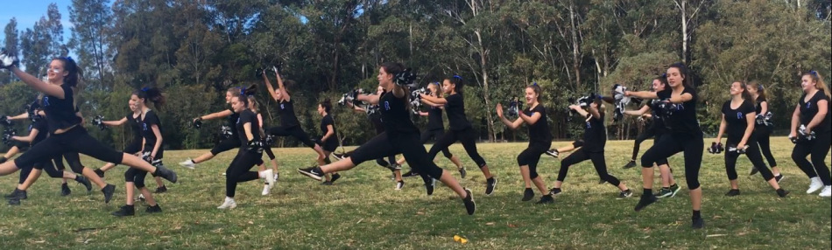

Contributor details
Denise Lofts (denise.lofts@det.nsw.edu.au) 17/4/19
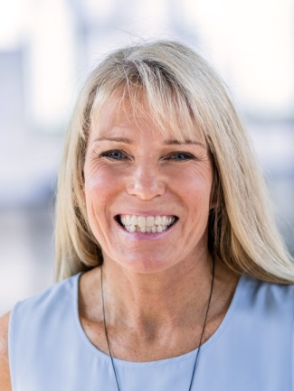
Denise has been Principal of Ulladulla High School since 2013, previously Principal of Marsden High School. Currently she is a member of the SPC Executive with particular responsibilities for Health and Safety and Aboriginal Education. Her current interests also include future focussed learning, particularly authentic cross-curricular project work, mindfulness and principal wellbeing. In addition, Denise is currently working on her Doc Ed with UNSW with a focus on rural and remote school leadership.

