Primary Presentation Day 2018
Greg Wilson

Welcome official guests [names of dignitaries]
Welcome parents, staff and students to the Primary Presentation Day for 2018.
I would like to acknowledge the traditional owners of this land, the Githabul people, and pay my respects to the Elders both past, present and future. I also pay my respects to any Elders present. Together we walk towards the future – thanks [Name of Aboriginal Elder] for her welcome.
Today provides us with an opportunity to reflect on 2018.
We also announce our captains for 2018. These students play an important role within the school. They have been elected by their fellow students as their representatives. It is an honour that I am sure they will fill well. My thanks for the role that our outgoing captains played this year [Names of outgoing captains].
Our students have tremendous opportunities in many areas such as music, robotics, debating, spelling and sport. The range of opportunities increases as our student progress through school.
Woodenbong Central School is much more than buildings, curriculum and resources. Connections and relationships are at the heart of the school. These connections are deep and can assist learning.
Looking around the hall today we can easily see the connections to, and relationships with, Woodenbong Central School. The number of parents, grandparents and great grandparents who have children here and also went to school here. Some even worked or now work at the school. They are all deeply connected to Woodenbong Central School and understand the importance of opportunities. Many assist and provide these opportunities. New parents and students quickly see Woodenbong Central School as their school. All have a desire to make the school better for the benefit of the students.
We have new mural on the walls of the primary stairs. Not only is it a great piece of art, it demonstrates in many ways our connections with our Communities. The stories behind the images are even more important. The stories literally symbolise the sharing of local knowledge, and the school has a responsibility to keep and appropriately share that knowledge. It demonstrates problem solving and the role the whole community plays in problem solving. I thank everyone involved with the mural students – [Name] for the scaffolding, [two names] but most of all [two names] for their time and talent for an awesome mural. Can I call [two names] to accept this small token of our appreciation.
One of the roles of schools is to prepare students for their futures. Our kindergarten students will be in the workforce in 2031. It is hard to imagine what that world may be, however the collective opportunities, values and the importance of community will hold them in good stead.
The foundational literacy and numeracy skills, followed by practice of applying those skills, along with comprehension, inference, critical thinking, problem solving, effective communication in all media, plus collaboration are the essentials for any modern learner. The so-called soft skills of communicating, innovation, creativity and interpersonal skills are becoming increasingly important. These are skills all students will need after school.
At Woodenbong Central School we have an enormous number of talented students – students who excel academically, who are talented musicians, dancers, sports people and students who a civic minded – and have a strong social conscience.
Today we can celebrate the successes of some of those students. However, all our students can be proud of their achievements this year as they always try their best, always try to help others and they strive to improve.
I would like to thank those who volunteer their time for the benefit of our students, whether this be with reading, scripture, in the library or within our classrooms. Our volunteers provide an invaluable service for our students. I also thank our parent organisation the P&C, as well as the AECG who play an important role supporting our students at school.
Woodenbong Central School is a fantastic school. We will continue to work with all members of our community to make Woodenbong Central School an even better school. That is a safe place for our students to learn and grow as individuals. We can do this by us all working together.
In 2019 we will expand on what has been working well, making the necessary tweaks keeping in mind the strengths of our community, connections and relationships. These have benefited our students of the past, our students of today and they will certainly benefit our students of tomorrow.
Congratulations to all of today’s award winners. Your hard work has been recognised today.
To all members of the Woodenbong Community I wish you a safe and happy Christmas and holiday period.
Thank you.

Contributor details
Greg Wilson (greg.wilson@det.nsw.edu.au ) 21/4/19
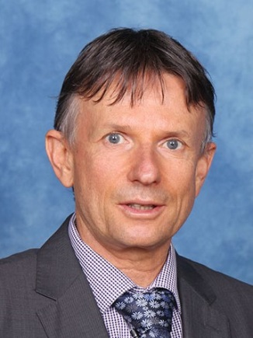
Greg is Principal of Woodenbong Central School, a position which he has held since 2008. In addition, he is a Member of the SPC Executive with responsibility for Learning and Business software, Aboriginal Education, Learning, DoE systems and he also represents the SPC on numerous Program Control Groups.

