Student Excellence Ceremony Term 2 2018
Fiona Walsh

Good morning. I’d like to start today’s proceedings with a quote from Anatole France:
“To accomplish great things, we must not only act, but also dream, not only plan, but also believe.”
The West Wallsend High School Excellence Assembly is a ceremony which recognizes students from each year who have acted, dreamt, planned and believed in their own education, demonstrating the achievement of personal excellence.
We are here today to celebrate that success and it is my pleasure to welcome firstly students, their dedicated parents and our hardworking educators.
It has been an amazing experience during this semester to work closely with dedicated teachers at West Wallsend who have a genuine passion and dedication for the education of students in their care. For that reason I would like today’s ceremony to also recognize the achievements of these hardworking professionals who set high expectations for students through engaging learning environments.
It is only fitting that we acclaim the highest achievers. To gain first place or receive an academic excellence award is an exceptional achievement, and it deserves to be properly recognised as such. But without underestimating the significance of our academic accolades, we must remember that they are not the only measure of our school’s excellence.
We must always be focused on our essential role in encouraging and developing well-rounded individuals who will be responsible, articulate, and community minded-citizens, who can think for themselves, form their own opinions, and who will be empowered to take their place in leadership roles in our ever-changing society.
At West Wallsend, we continue to educate and empower our students through our holistic approach to teaching and learning. Our students are given a wide range of opportunities through our curriculum and co-curriculum activities to develop their individual and varied talents.

Semester one has seen many achievements and opportunities across all aspects of school life. I would like to outline just a few of those achievements and opportunities:
The amazing CAPA Showcase held on April 10 representing students and staff from dance, music and art was a fantastic event. A wide variety of artwork was on display including, sculpture, drawings, paintings, digital drawings and photography. Musicians and singers rocked the stage and the dancers were spectacular with lots of high energy pieces. Leading on from this was the wonderful student involvement in Star Struck. Our clever dance students also auditioned and were successful in being accepted into the Hunter Dance Festival in July this year.
John Joseph Workshops have been an absolute hit this year with not only all of our students being involved during week 2 this term, but also a huge number of parents attending the night workshop held on May 9. Students from Years 7-10 enjoyed a half-day workshop and our seniors a full day. John worked with students explaining how their brains work and techniques they can use to improve their study, memory retention, motivation and aspirations. With senior students, he went into greater depth, explaining the importance of healthy sleep habits and discussing career profiling.
Our senior students have shown very high levels of engagement in the Step-Up program. The program has enabled our seniors to be well equipped to achieve their study goals, with teachers providing a variety of additional curricular support including English Kickstart Wednesday afternoons, English Breakfast Club Friday mornings, Maths and Milo Tuesday mornings as well as weekly HSC masterclasses held on Thursday afternoons on different subject areas. Seniors also attended the Singleton HSC Seminar day and additional workshops with Elevate Education where they learnt study tips and time management skills. Elevate Education also offered a parent session last Tuesday to assist parents and carers in supporting their child’s learning.
Student awards. We are a positive behaviour for learning (PBL) school and this year we have gone fully electronic with the awards system. This Semester teachers have awarded 8540 GOTCHAs and 353 Excellence Commendations. This equates to:
- 272 Bronze Awards
- 82 Silver Awards
- 30 Gold Awards.
These will be presented to students along with the Semester 1 report on Friday 6 July.
And who could forget our PDHPE assembly Monday, emphasizing the importance of movement? Our Facebook page received well over 2000 hits.
These are but a few of the many achievements and opportunities within the school during semester one.
So, back to the high achieving students in the hall. Well done and congratulations on your success today. Continue to act, dream, plan and believe in yourselves and your education. We as a staff believe in your ability to succeed and strive for personal excellence. Let’s continue to see it.

Contributor details
Fiona Walsh (fiona.walsh@det.nsw.edu.au ) 19/4/19
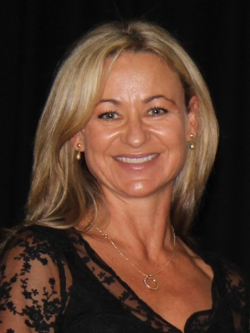
Fiona has been Principal of West Wallsend High School since 2014. Currently she is also President of NSWSPC Hunter Region, Leader of the Professional Learning Reference Group and a Member of the SPC Executive. The focus of Fiona's PhD was professional learning. Her current interests include sport.

