Year 11 – some motivation suggestions
Dianne Marshall

Editor’s Note: The following four motivational extracts come from Dianne’s Year 11 Presentation Day speeches over the last few years.

The British Olympic Cycling Team’s secret of success
I read a story recently about the secret of success behind the medal-winning British Olympic Cycling Team. According to their coach, their key to success involves the accumulation of small gains.
He says it’s the little things that make the difference, when winning in an event might mean being better by only a fraction of a second.
The coach is so careful about small details that he even chooses the cyclists’ mattresses, because he believes they must have a very good night’s sleep before a big race.
Because the all-important thigh muscles of a cyclist can cool down and tighten up in the minutes waiting for a race to begin, his cyclists wear special heated shorts that keep their muscles in peak condition. It is the small detail that makes the difference.
Of course, to do well in any field you must work hard on every aspect. Champion cyclists must be fit and strong, in peak physical condition, ready for competition after hours and hours of training, fully informed about tactics and strategy.
But to stand out from the field, what everyone needs is that attention to detail, the willingness to prepare so thoroughly that you know you are doing the best you possibly can.
For a student that may not mean a special mattress or heated shorts, but it could mean making sure you get enough exercise, sleep and healthy food.
Then you would need to look carefully at every aspect of your work and concentrate on the details that will lift your performance.
The recent reflection survey that you completed revealed that many of you have identified that you need a study timetable; a better balance between work, sport and study; more focus on writing extended responses and making class notes; and so on.
It is now a matter of not just thinking about it but putting your plan for success into action - and doing that every day.
The lesson we learned from the inspiring athletes at the Olympics was not that they rely on natural talent to win the medal. Rather, we understood that behind every participant there lay hours and days and weeks and years of practice and that essential ingredient, attention to detail.
So I ask you to think about this: What will be the secret of your success?

Principles that Year 11s should keep in mind
There are several important principles that you should keep in mind if you are to achieve your goals in the HSC:
1. How you think is everything.
- Always be positive. Think success, not failure or doubt.
- The moment you say to yourself “I can’t”, then you won’t.
- Positive things happen to positive people.
2. Decide upon your true dreams and goals.
- Goals are those concrete, measurable stepping stones of achievement that track your progress towards your dreams.
- What are your goals?
- Write down your specific goals and develop a plan to reach them.
3. Take action.
- Goals are nothing without action.
- Be like Nike and “Just do it”.
- Every day try to take some action towards your goals. It may be small, but it’s still an action.
4. Never stop learning.
- Becoming a lifelong learner would benefit us all, and it’s something we should instill in every generation.
- It’s funny that once you’re out of school you realise how enjoyable learning can be.
5. Be persistent and work hard.
- Success is a marathon, not a sprint. Never give up.
- I think every story of success I have read entails long hard hours of work. There is no getting around this and there is no free lunch.
- But, if you’re working towards something that you’re passionate about or determined to achieve, then is it really work?
6. Learn to analyse details.
- Get all the facts, all the input. Learn from your mistakes.
- I think you have to strike a balance between getting all the facts and making a decision with incomplete data – both are traits of successful people. Spend time gathering details, but don’t catch ‘analysis paralysis’.
7. Focus your time.
- Don’t let other people or things distract you.
- Remain laser-focused on your goals and surround yourself with positive people that believe in you.
- Don’t be distracted by people or tasks that are not helping you achieve your goals.
8. Don’t be afraid to innovate.
- Be different. Following the herd is a sure way to mediocrity.
- Follow through on that break-out idea you have. Ask yourself “What would I do if I wasn’t afraid?”
9. Deal and communicate with people effectively.
- No person is an island. Learn to understand and motivate others.
10. Be honest and dependable.
- Take responsibility, otherwise numbers 1 – 9 won’t matter.

Hang in there
I was thinking about what I could say to encourage you, as new Year 12 students, to keep focused for the upcoming year.
Recently I was showing the SRC Executive some images I was going to use to reinforce my key messages about the importance of attendance, and that there are no shortcuts so keep working, seek help before it becomes too big and enjoy yourself.
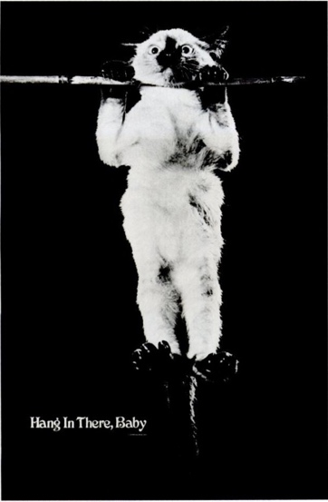
One member of the SRC Executive absolutely hated the ‘Keep Calm’ poster that I had found and when I asked, he suggested I use the ‘Hang in There’ cat. So I went and had a look for images, and found the most extraordinary history behind this photo:
In 1826 the French inventor Nicephore Niepce (pronounced: Nee se foe Niepse) produced what is widely considered the first permanent photograph. Few know that this seminal image consisted of his pet kitten, Croissant, humorously hanging from a silken rope.
Due to an exposure time that was a ghastly eight hours, Croissant was forced to dangle for what seemed an eternity. Niepce lovingly murmured “Coup dedans la” to keep the kitten motivated and aloft, and thus the phrase “Hang in There” was first uttered in French. Alas, poor Croissant was never to be the same, noticeably limping from that day forth.
Kittens have been hanging in ever since, bringing smiles to faces and joy to barren walls the world around. At times it seems that the medium of the poster was invented for their great purpose.
The unfortunate trailblazer, Croissant, did not suffer in vain. A rich history would follow, a history that would find kittens hanging in there amongst the company of kings and queens, captains of industry, presidents and dignitaries.
These selfless kittens would lift spirits the world over. Hospital cubicles would burst with brightness and hope when a kitten hung precariously from the walls. During the Great Depression ‘Hang in There’ posters were used as stock for soup, their message filling bellies with optimism. Some conspiracy theorists even argue that the US became involved in the Vietnam Conflict only after Ho Chi Minh was seen hanging from a branch with a kitten sandwich in one hand. Dick Cheney (former USA Vice President under President George W Bush) was said to have a secret room in his house, one with ‘Hang in There’ posters plastered floor to ceiling, and the soft sounds of Air Supply on continuous loop.
Today we are celebrating the fact that you are at a halfway point. For most of you, by this time next year, you will be in the final stages of your HSC examinations. It is time now for you to build upon what you have begun and achieved so far. It is important that in a year’s time you can look back and know that you have given it your best.
So my message is simple: Hang in There. One year is not really all that long in the context of your life to come.

Yes I can
Each year I try to find something different to say at these presentation ceremonies.
Usually during the year I see or hear something that speaks to me, and especially for the Year 11 Presentations where I am trying to find a way of keeping you motivated for the next 12 months. This year I couldn’t go past the film which was produced for the 2016 Paralympics, which had the theme of ‘Yes I can’.
Let’s have a look at it again.
Show video: https://www.youtube.com/watch?v=vzjuQoNM534
It still gets me every time I look at it. There is even that section where a school principal says “No you can’t.” Well not this one! I want everyone to succeed in their own special way. You are at a halfway point and it is time for you to focus on your goals, have high expectations of yourself and be excellent in all ways.
For most of you, by this time next year, you will be in the final stages of your HSC examinations. It is time now for you to build upon what you have begun and achieved so far. It is important that in a year’s time you can look back and know that you have given it your best.
One year is not really all that long in the context of your life. So my message today is simple – say “Yes I can”.

Contributor details
Dianne Marshall PSM (dianne.marshall2@det.nsw.edu.au) 29/4/19
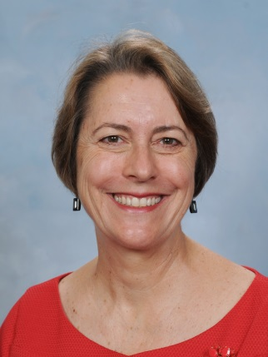
Dianne has been Principal of Coffs Harbour Senior College since December 2013. Currently she is also a President of NSWSPC North Coast Region and a Member of the SPC Executive with the Student Wellbeing Portfolio and Senior Schools Interest Group. Her current interests include riding her e-bike, walking and reading.

