Year 11 – the Pygmalion Effect
Dianne Marshall
Editor’s Note: The following text is an extract from one of Dianne’s Year 11 Presentation Day speeches.

I had an interesting conversation with one of our teachers here, about the impact of being in an adult learning environment. He said it was the ‘Pygmalion Effect’, which is also known as the self-fulfilling prophecy.
Perhaps I can explain this in the following way: We have high expectations that all of you will achieve to the best of your ability. That you will be focused and work hard. That you will seek help in order to improve. This adult learning environment and the high expectations of your teachers has resulted in students regularly achieving above their expectations. We believe in you and act that way towards you. This reinforces your belief in yourself and your performance will rise accordingly.
I was really fascinated by our conversation and decided to do a little research and this is what I found.
Please see attached PowerPoint: Year 11 – the Pygmalion Effect (Dianne Marshall) PPT slides
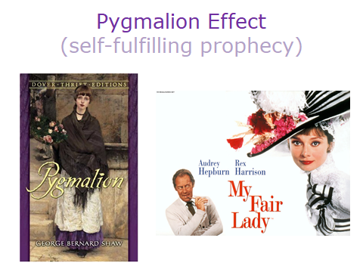
Show Slide 1
The Pygmalion effect is demonstrated in George Bernard Shaw’s play ‘Pygmalion’, which was made into the classic film, My Fair Lady.

Show Slide 2
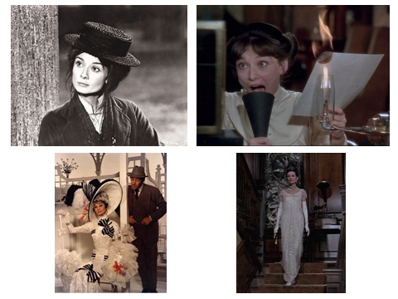
Professor Henry Higgins, a linguist, made a bet with Colonel Pickering that he could take a Cockney flower girl and turn her into a duchess.

These were very high expectations in the context of the time in which the play was set. I love some of these images of Audrey Hepburn as the flower girl and then practising her “h”s. Then going to the races, and all dressed ready for the Grand Ball. The film is worth watching again and I did have fun revisiting it for this speech. The subject of his experiment, Eliza Doolittle, actually makes the point of the Pygmalion Effect quite clearly in the following excerpt from the movie:
Show Slide 3 and play movie embedded in that slide (Please note: You need to have QuickTime loaded to play this file)

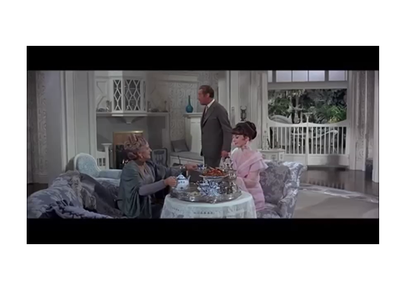
The important phrase here is how she is treated.

So what does this look in a school setting?
Show Slide 4
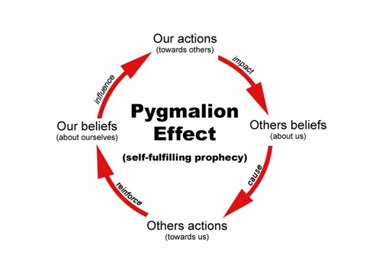

In 1968 two psychologists, Rosenthal and Jacobson, conducted an experiment in public elementary schools in the US. They told teachers that certain children could be expected to be ‘growth spurters’, based on the students’ results on the Harvard Test of Inflected Acquisition. In point of fact, the test was non-existent and those children designated as ‘spurters’ were chosen at random. What Rosenthal and Jacobson hoped to determine by this experiment was the degree (if any) to which changes in teacher expectations produce changes in student achievement. Their hypothesis was that high teacher expectations of students will produce changes in student achievement.
Conversely, low expectations produce negative student achievement. They found that after one year there was evidence that teacher expectations worked as a self-fulfilling prophecy. If teachers were led to expect enhanced performance from some children, then those children did indeed show that enhancement.
In 1968, another researcher, Schrank, made a similar experiment, showing the self-fulfilling prophecy phenomenon exists at the group level as well. Schrank told teachers that their classes were made up of students of particularly high or low learning potential. They were once again a random group of students. The high potential group students were later found to perform better and learn more than the low potential group students. However, it is not as simple as it sounds. They also found that as the students got older the effect was lessened by other influences, including student motivation and learned behaviour.
Research since Rosenthal and Jacobson’s original study has determined that the Pygmalion Effect applies to all kinds of settings, from sports teams to the military to the corporate workplace.
So what is the Pygmalion Effect at the Senior College? It is the adult learning environment.
All the teachers have high expectations of each of you. They are determined to help you to achieve more than you probably thought you could. We provide a challenging environment based on those expectations and with that, there is ample support to ensure you succeed at even higher levels. You need to have high expectations of yourself, as do your parents. Always remember it can be a self-fulfilling prophecy.
We are here today to celebrate the results of those high expectations. You are at a halfway point and it is time for you to focus on your goal, have high expectations of yourself and be excellent in all ways. For most of you, by this time next year you will be in the final stages of your HSC examinations. It is time now for you to build upon what you have begun and achieved so far. It is important that in a year’s time you can look back and know that you have given it your best.
One year is not really all that long in the context of your life to come, so my message is simple: Remember the Pygmalion Effect – Believe in yourself and have high expectations, because we have them of you.

Contributor details
Dianne Marshall PSM (dianne.marshall2@det.nsw.edu.au) 29/4/19
Dianne has been Principal of Coffs Harbour Senior College since December 2013. Currently she is also a President of NSWSPC North Coast Region and a Member of the SPC Executive with the Student Wellbeing Portfolio and Senior Schools Interest Group. Her current interests include riding her e-bike, walking and reading.

