Year 12 Graduation 2016
Greg Wilson

I thank [Names of Aboriginal Elders] for their welcome to Country. I would like to acknowledge the traditional owners of this land, the Githabul people, and pay my respects to the Elders both past, present and future as we walk together into the future.
This is a very important date on our school calendar. We say farewell to the current year 12 students and induct our captains and vice captains for 2017. To our outgoing Captains I say thank-you very much for your time, leadership, effort and support of both the school and our students. You have done an outstanding job in many different forums – [Names of fours school captains]. You have raised the bar quite high for our incoming captains.
Today is a significant milestone for our Year 12 students. It marks both an end and a beginning – an end to classroom lessons but not an end to learning. It is the beginning of your post-school lives. What you have learnt at Woodenbong Central School will hold you in good stead for the next phases of your lives.
Today we all have the opportunity as a school to reflect on Year 12, their efforts and achievements, their journey both as people and as learners at Woodenbong CS.
You may not be the largest Year 12 we have ever had at Woodenbong Central School, but you are very representative of our communities – from Old Bonalbo to Legume. Community and tradition are very important to us all.
I love the fact that our kindergarten students lead our year 12 students into the assembly today. It says so much about our school. Looking at your kindergarten pictures yesterday we can see how much you have changed and grown as young people. There are been many who have both joined and left your cohort since kindergarten. As a group it is wonderful to see how inclusive you are, but you are definitely all individuals.
Student
[Name] | Shows the importance of following your dreams – the importance of a school to be flexible to meet needs – working with community
[Name] | Has taught us all a lot
[Name] | We made it – good to see you have completed school
[Two names] | Growth, experience in making deadlines –– maybe one day I get photo of great work in primary industries
[Name] | Always looking after others – caring
[Name] | Captain involvement in his quiet way
[Name] | Early starts, jumpers, determined, an organiser
[Name] | Path to Captain – maths classes have the biggest rooms for our smallest class, ecstatic that her last formal lesson was mathematics
[Name] | Has achieved many wonderful things;, breakfast program, continue to askquestions

We wish you all the best. We know that you are well prepared to enter a world that is constantly changing. You have developed the skills to succeed in whatever you choose. We will be very interested to follow your progress and see where each of you are in 2028, when our current kindergarten students graduate.
Education is a partnership. We must acknowledge the role that the school, your parents, family and the wider Communities have played in helping you reach this milestone today – and the role they will continue to play to help you achieve your dreams.
I would like to thank their Year Adviser, [Name of teacher] who has guided you through the maze that is high school, and who has done a great job helping all members of year 12 to be where they are now.
Year 12, I wish you well for your examinations. They are important but not the bee all an end all. There are many ways to achieve your goals and dreams.
The school is proud of where you are today and I encourage you to make the most of what you are taking from your school years. I am sure that you will continue to make the most of your opportunities.
Thank you.

Contributor details
Greg Wilson (greg.wilson@det.nsw.edu.au ) 21/4/19
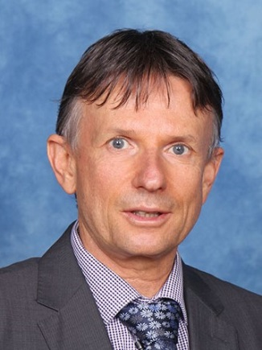
Greg is Principal of Woodenbong Central School, a position which he has held since 2008. In addition, he is a Member of the SPC Executive with responsibility for Learning and Business software, Aboriginal Education, Learning, DoE systems and he also represents the SPC on numerous Program Control Groups.

