Year 12 Graduation 2016 – pots of paint
Dianne Marshall

Good morning – and a very warm welcome to everyone. We are trying out a new venue this year. We felt it was really important that everyone could come along and join in the celebration. This includes our special guests, sponsors, parents, carers, friends, staff and most importantly our graduating Year 12 students.
Being the Director of the Senior College is an incredibly rewarding position. I feel privileged to have been able to spend time with many of you over the past few years – to be part of the holistic educational experience that is on offer here at the senior college, and to help you start on the journey to achieving your dreams and aspirations. I acknowledge it must have been a big decision to leave the known and venture into the unknown. You have made new friends and learned more about yourself – what you like doing, what you definitely don’t like doing and how you learn best. I believe it was an excellent transition strategy as you are now well prepared to take the next big step.
It is a bit like starting from this image: Slide 1: Pots of paint
Your world at the Senior College has been remarkably structured like these pots of paint. Teachers are experts at their subjects and the examinations which you are about to commence are your chance to show how much you know, understand and can apply about these subjects.
When the exams are over you will find that it is now time for you to take all this knowledge and to start making your own picture.
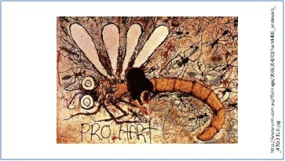
Slide 2: Pro Hart advertisement

I was thinking about this concept and remembered the Stainmaster carpet advertisement in the 1980s, where Pro Hart, a famous Australian artist, recreated one of his Dragonfly images on the carpet using a variety of substances.
It all looks quite simple in the picture but let’s look at the 2010 version where his grandson replicated the picture his own way.
Show video: https://www.youtube.com/watch?v=gJuYppiN5yM
Throughout your life you will be using all the paint pots from your schooling to create your own picture.
However, there are additional skills that you will need to hone to be successful after school. For some of you these skills are already highly developed, and you probably didn’t recognise when you have been learning in each of your subject paint pots.
Today I am going to focus on four C’s: Collaboration, Creativity, Critical Thinking and Communication.
Slide 3: Collaboration
Collaboration is all about working in teams. As the saying goes there is no “I” in team.
It is not easy to work in teams. You have to be able to manage team dynamics, have lots of empathy, realise that you are not always right and that others might have a unique solution you haven’t thought of. We are all different so that is incredibly challenging, especially when we have to work together to achieve a goal.
We often seek out like-minded people when working on a project, thinking that it will make everything go smoothly. In reality it is actually important to have a team with lots of different talents who can challenge ideas, be creative and cause disruption.
For example, you might need someone who reads all the fine detail in documents, another person might be a great researcher. Then there are those who can make it come alive on the screen diagrammatically. Who can put the colours and sound around the theme.
Harry Hart and his grandfather Pro Hart had to work in a team environment to create the dragonfly and I am sure there were lots of differences during the process of creating the ad.
Slide 4: Creativity
So let’s explore creativity a bit further.
What do you do when you have a great idea? Does it all seem too hard so you do nothing? Our world needs people who say “Yes I can”. These ideas could be potential money-making opportunities. Do you know how to make them happen? Who would you seek help from? Do you see opportunities which will make a difference to the environment, and the people of the world? Do you have the skills to turn them into action? Who would support you to do this?
Slide 5: Critical Thinking
There will always be problems that need to be solved. Can you solve problems and make effective decisions using all the resources that you have available? We need people who can make connections and identify patterns. Think of all the researchers who painstakingly experiment, reflect and refine their work so that they can make a difference in the real world. Medical research, technology, robotics, sustainable energy and the list goes on. What will be your pathway?
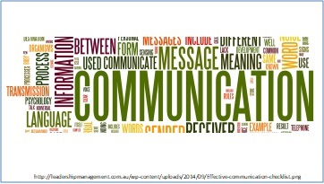
Are you able to think critically to design and manage these projects?
Slide 6: Communication
Whenever there is an issue at a workplace, school, club or other group the first complaint is about lack of communication. I have always felt that it is important to ‘over-communicate’. It is all about listening, sharing ideas, getting everyone involved in the decision-making process. There is nothing worse than not knowing what is going on. As the saying goes, ‘living in a vacuum’.
So use the tools that you have available in this wonderfully connected society to communicate wisely and effectively.
I feel confident that each of you in your own way can use what you have learned here at the senior college to continue learning and functioning effectively in society. When you start making your own picture you will have to embrace the messiness, get your hands dirty and live life to the fullest. Set goals, plan, take risks, make mistakes and ENJOY all the different experiences and opportunities. You will continue to develop your collaboration, creativity, critical thinking and communication skills which will help to shape your picture. And importantly - Remember to give something back along the way.
Each of you is unique and your contribution is important. On behalf of the staff, I wish you every success in the upcoming examinations. I also wish you a happy life full of joy and wonder.
Today we acknowledge student achievements and contributions to the college. Shortly each of you will be presented and we will hear some of your accomplishments. However, before we start these presentations, I would like to acknowledge the support and cooperation of many people and organisations.
- Firstly, our partners, Southern Cross University and the North Coast Institute of TAFE. We have a wonderfully innovative partnership at the Coffs Harbour Education Campus. There is always something new happening around the campus. This place is unique and offers many opportunities for our students.
- Also a big thank you to the staff of the Senior College who work tirelessly to support each of you to achieve your potential. I am always amazed when I walk around the college and see students in offices with the staff getting individualised support, the extra lessons during the holidays, and the after school hours given to support HSC programs and major works.
When thinking back to the 4 C’s can I say that this is an extraordinarily collaborative team of people who are always using critical thinking to develop creative educational opportunities for all students. And it goes without saying that effective communication is the key. We have high expectations for each of the students in our care and we know that each one of you has been given the knowledge and skills to embrace the world and make something of it.
- A special thank you to the parents and carers who have supported their young adults through the stress of assessment tasks and examinations. I know sometimes your advice is ignored even though it was coming from experience. I am sure that each student here will make the time to say thank you today and again at some time in the future.
- To our sponsors, many of whom are with us today and will be part of the ceremony. Thank you for your generous support. The College greatly values your sponsorship.
- Special thanks to everyone involved in the organisation and running of today’s ceremony – especially at a new venue.
It now gives me great pleasure to announce the top ATAR award for 2015. This award is sponsored by Southern Cross University and is presented by Professor David Lynch.
Thank you.

Contributor details
Dianne Marshall PSM (dianne.marshall2@det.nsw.edu.au) 29/4/19
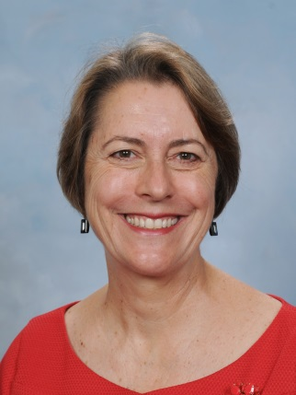
Dianne has been Principal of Coffs Harbour Senior College since December 2013. Currently she is also a President of NSWSPC North Coast Region and a Member of the SPC Executive with the Student Wellbeing Portfolio and Senior Schools Interest Group. Her current interests include riding her e-bike, walking and reading.

