Year 12 High Achievers Ceremony 2019
Fiona Walsh

Welcome parents, staff, students and most importantly our HSC students of 2018.
We are here today to recognise academic excellence achieved by our year 12 students in last year’s Higher School Certificate. The last two years in particular have shown significantly improved performance of students in the HSC.
As past Year 12 students, each one has had to display discipline, commitment, determination, high order thinking, rigor and excellent time management to pursue and attain academic excellence in the HSC. These traits will serve them well as they begin to study for their chosen career paths which are quite varied.
The career paths our Year 12 students have chosen are as follows:
[Names of 13 students and their post school destinations and HSC achievements].
We as a school will continue to provide a quality education for all existing students through a myriad of programs and initiatives that engage students in learning, promote passionate teaching and exceed all expectations.
My last comments are directed towards our very clever 2018 HSC students:
You are ready, willing and more than able to grasp life’s opportunities that will come your way in the next few years.
May your years ahead continue to be characterised by the traits we know you well for – your hard work, commitment, dedication and high efficacy.
May you continue to lead by example and achieve your goals.
May your successes be many and your tribulations be few and far between.
We wish you everything that you so richly deserve in the years ahead – it has been an honour and a privilege watching your progress and success.
Well done class of 2018.

Contributor details
Fiona Walsh (fiona.walsh@det.nsw.edu.au ) 19/4/19
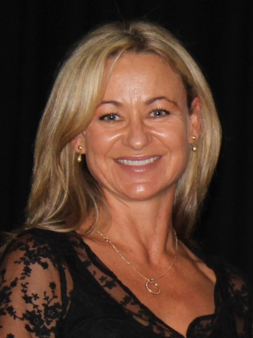
Fiona has been Principal of West Wallsend High School since 2014. Currently she is also President of NSWSPC Hunter Region, Leader of the Professional Learning Reference Group and a Member of the SPC Executive. The focus of Fiona's PhD was professional learning. Her current interests include sport.

